Report on Antarctic tourist flows and cruise ships operating in Ushuaia during the 2018/2019 Austral summer season

English version provided by the author

Report on Antarctic tourist flows and cruise ships operating in Ushuaia during the 2018/2019 Austral summer season
Information Paper presented by Argentina
Summary
This paper provides information about the flows of passengers and vessels that visited Antarctica during the 2018/2019 Austral summer season, operating from the port of Ushuaia. The number of voyages that took place, passengers and their nationalities, average number of crew per vessel, expedition staff and the registers of ships, are included as well.
Introduction
Ushuaia (54º 48’ S - 68º 19’ W), located at the southern tip of South America, is the most active gateway city to Antarctica in terms of Antarctic ship-borne tourism since mid-1990´s, concentrating approximately the 90% of the worldwide ship-borne Antarctic tourist activity.

The development of airport and port infrastructure in Ushuaia has contributed to facilitate Antarctic cruise ships operations through the port of Ushuaia. In addition to the short distance between Ushuaia and the Antarctic Peninsula, those works allowed tour operators to extend the frequency of their Antarctic operations during the tourist season.

Regarding Antarctic ship-borne tourism that operates from the port of Ushuaia, we can make a clear distinction between different types of vessels, according to their activities in the Antarctic Peninsula area. On the one hand, vessels that make landings at different locations; and, on the other hand, vessels of a much larger size which only sail Antarctic waters without enabling landings. Moreover, a further distinction can be made when looking into the services the vessels require from the port of Ushuaia: those vessels that arrive in Ushuaia as part of a more extended South American and Antarctic itinerary, and those which call in Ushuaia’s port as their summer base of operations. Generally, in the latter case, operations carried out in Ushuaia involve passenger changeover, using the city’s airport, port and maritime services, as well as the general supply of provisions and tourist services. Finally, it should be noted that at the beginning and at the end of the Antarctic tourist season, most vessels arrive to and/or depart from the port of Ushuaia, and engage in positioning voyages from or towards other destinations.

In order to present the status of tourist flows of visitors and vessels that, through Ushuaia’s port, visited Antarctica in the 2018/2019 season, data was collected from the ship’s dispatches provided to Prefectura Naval Argentina (Argentine Coast Guard), national competent authority to that effect. In some cases, this information was compared to the itineraries provided by tour operators on their websites, and to data obtained from alternate sources. Such information is used to prepare a database for each Antarctic tourist season.

This document updates the data provided in similar papers presented by Argentina to the Antarctic Treaty Consultative Meetings since 2009, providing information that may contribute to discussions related to Antarctic tourism.
Brief review of the Antarctic tourist flows and cruise ships that operated through Ushuaia during the 2018/2019 Austral summer season
The 2018/2019 tourist season started on October 7th when the IB Kapitan Khlebnicov (Quark Expeditions) set sail for Antarctica, and finished on April 4th with the arrival of the MV Ushuaia (Antarpply Expeditions) to the port of Ushuaia. There were a total of 278 voyages run by 35 vessels, including the SV Bark Europa. January was the busiest month regarding the number of Antarctic voyages (26.26%), followed by December (23,74%) (See Figure 1).

Figure 1 - Number of Antarctic voyages through the port of Ushuaia per month.
Ushuaia, 2018/2019 summer season

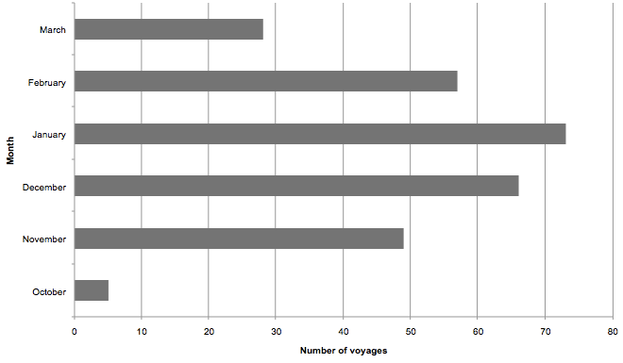
Source: Universidad Nacional de Tierra del Fuego, Antártida e Islas del Atlántico Sur (UNTDF), based on data collected from 2018/2019 ship’s dispatches, Argentine Coast Guard.
During the 2018/2019 season, 55,282 visitors went to Antarctica, using Ushuaia as a connection port from and/or to the Antarctic territory. Three passenger categories can be identified: a) those that departed from and returned to the port of Ushuaia, b) those that either departed from or arrived in Ushuaia -that is, passengers who went through Ushuaia only once, either on arrival or departure to Antarctica- and c) those that visited Ushuaia in transit on their way to or from Antarctica, embarking or disembarking at other ports (See Table 1). In the first case (a), only the departure of the vessels was considered in order to count the passengers. In the second case (b), both the passengers who arrived at, and the ones who departed from the port of Ushuaia were taken into account, because several vessels either started or finished their voyages in other ports, either combining with other means of transport such as flight-cruise, or visited Antarctica as part of the beginning and/or end of season voyage, operating locally (in Ushuaia) during the rest of the season. Finally, the last case (c) refers to vessels in transit, with passengers that were counted upon arrival or departure, depending on the case when calling in at the port of Ushuaia.

Table 1 - Breakdown according to ships’ itineraries. Ushuaia, 2018/2019 summer season
 | a) EMBARKATION AND DISEMBARKATION IN USHUAIA | b) EMBARKATION OR DISEMBARKATION IN USHUAIA | c) IN TRANSIT IN USHUAIA | TOTAL
NUMBER OF VISITORS | 36,977 | 5,242 | 13,063 | 55,282
PERCENTAGE OF VISITORS | 66.89% | 9.48% | 23.63% | 100%
NUMBER OF VOYAGES | 222 | 44 | 12 | 278
PERCENTAGE OF VOYAGES | 79.86% | 15.83% | 4.32% | 100%

Source: UNTDF, based on data collected from 2018/2019 ship’s dispatches, Argentine Coast Guard.
Antarctic visitors travelled in tourist vessels of different sizes. In this regard, a distinction was made, according to the provisions of Measure 15 (2009) adopted in the XXXII Antarctic Treaty Consultative Meeting, between vessels that transported 500 passengers or less, and those that transported more than 500 passengers. Therefore, four (4) vessels carried more than 500 passengers completing seven (7) trips in total and transporting 10,964 passengers, representing 19.83% of the passengers that visited Antarctica.

The average number of crew members and passengers, as well as the number of voyages per vessel are presented in Table 2. Figure 2 shows passenger averages per vessel.

Table 2 - Average number of crew and passengers per vessel and number of voyages.
Ushuaia, 2018/2019 summer season

VESSEL | AVERAGE CREW PER VOYAGE | AVERAGE PASSENGERS PER VOYAGE ^{(a)} | NUMBER OF VOYAGES
Akademik Ioffe | 54 | 107 | 3
Akademik Sergey Vavilov | 42 | 98 | 7
SV Bark Europa* | 57 | 0 | 4
Bremen | 104 | 150 | 4
Expedition | 77 | 132 | 12
Fram | 73 | 205 | 6
Hamburg | 171 | 352 | 3
Hebridean Sky | 77 | 97 | 9
Island Sky | 77 | 108 | 9
Kapitan Khlebnicov | 59 | 122 | 4
L´Austral | 143 | 216 | 10
Le Boreal | 143 | 210 | 8
Le Lyrial | 142 | 201 | 11
Le Soleal | 144 | 216 | 5
Midnatsol | 116 | 405 | 12
National Geographic Explorer | 86 | 166 | 10
National Geographic Orion | 64 | 114 | 10
Ocean Adventurer | 77 | 95 | 9
Ocean Atlantic | 104 | 198 | 13
Ocean Diamond | 102 | 192 | 14
Ocean Endeavour | 122 | 233 | 10
Ocean Nova | 34 | 65 | 7
Ortelius | 51 | 116 | 12
Plancius | 46 | 112 | 11
Polar Pioneer | 25 | 60 | 8
RCGS Resolute | 104 | 144 | 11
Sea Spirit | 72 | 125 | 11
Seabourn Quest | 379 | 420 | 5
Silver Cloud | 230 | 227 | 11
Silver Explorer | 120 | 128 | 6
Ushuaia | 41 | 87 | 16
Azamara Pursuit | 399 | 620 | 1
Celebrity Eclipse | 1231 | 2825 | 2
Prinsendam | 448 | 667 | 1
Zaandam | 587 | 1342 | 3
Note: vessels that carried more than 500 passengers are highlighted in grey; ^{(a)} staff members are also included in the average number whenever they were listed on the passenger manifests (expedition staff), circumstance present in at least 1/3 of the voyages; ^{(b)} the SV Bark Europa is considered a training vessel, declaring it takes only trainees on board, who were included on the crew list.
Source: UNTDF, based on data collected from 2018/2019 ship’s dispatches, Argentine Coast Guard.
Figure 2 - Average number of passengers carried per vessel on each voyage.
Ushuaia, 2018/2019 summer season

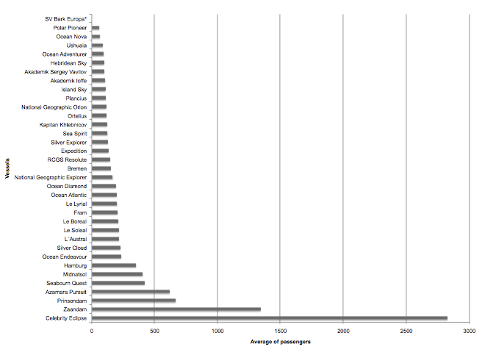
Source: UNTDF, based on data collected from 2018/2019 ship’s dispatches, Argentine Coast Guard.
Among the vessels in transit in Ushuaia, those that sailed through Antarctic waters without disembarking in Antarctica are noteworthy. As previously stated, these cruise ships completed itineraries around the southern parts of South America, or were involved in more extensive voyages and, on certain itineraries, they included navigating in waters close to the Antarctic Peninsula. Most of these vessels run “pendular” trips along Beagle Channel to connect ports located on the Atlantic and Pacific oceans, and visit Antarctica either from the Atlantic or from the Pacific. Table 3 provides an overview of the vessels that transported more than 500 passengers per trip, highlighting if the visit to Antarctica was before or after the port call in Ushuaia.

Table 3 - Cruise ships that carried more than 500 passengers.
Ushuaia, 2018/2019 summer season

VESSEL | ARRIVALS IN USHUAIA^{(a)} |  |  | DEPARTURES FROM USHUAIA^{(a)}
VESSEL | Date ^{(b)} | Crew | Pax | Date^{(b)} | Crew | Pax
MS Azamara Pursuit |  |  |  | 11/1/2019 | 399 | 620
MS Celebrity Eclipse |  |  |  | 24/1/2019 | 1,234 | 2,829
MS Celebrity Eclipse |  |  |  | 7/2/2019 | 1,227 | 2,821
MS Prinsendam |  |  |  | 1/2/2019 | 448 | 667
MS Zaandam |  |  |  | 25/12/2018 | 588 | 1,296
MS Zaandam | 21/1/2019 | 587 | 1,350
MS Zaandam |  |  |  | 7/2/2019 | 585 | 1,381
Notes: ^{(a)} Only the Antarctic voyages are represented above, and it is indicated whether visits to Antarctica were made before or after the port call in Ushuaia.
^{(b )}dd/mm/yy.
Source: UNTDF, based on data collected from 2018/2019 ship’s dispatches, Argentine Coast Guard.

Furthermore, 22 vessels ran regular voyages to and from Antarctica operating throughout the season from Ushuaia, and they account for 62.86 % of the total number of vessels that were analyzed. Each of these vessels made between 7 and 16 voyages to Antarctica, as indicated in Figure 3.

It is worth noting that the MV Ocean Nova, MV Polar Pioneer, MV Ocean Adventurer, MV Akademik Sergey Vavilov, MV Hebridean Sky, and Akademik Ioffe, operated differently than the rest of the vessels, as they did so directly from King George Island (Isla 25 de Mayo), South Shetland Islands (Islas Shetland del Sur), embarking passengers that flew in and out from Punta Arenas (Chile) in the months of December, January, February and March.

Figure 3 - Vessels that made most voyages to Antarctica operating regularly.
Ushuaia, 2018/2019 summer season

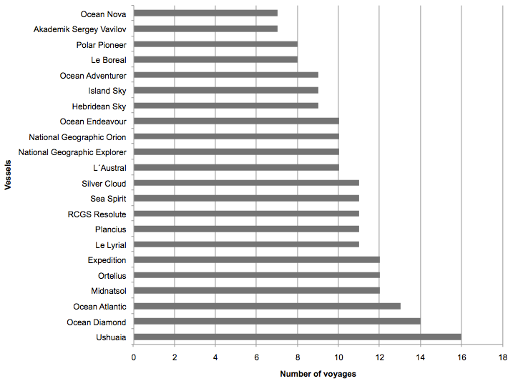
Source: UNTDF, based on data collected from 2018/2019 ship’s dispatches, Argentine Coast Guard.

Regarding visitors who went to Antarctica through the port of Ushuaia, the nationalities of passengers were registered. In this regard, more than 84 nationalities were identified, with most of the passengers being from the United States, followed by China, Australia, United Kingdom, Germany, France, Canada, Switzerland, New Zealand, Netherlands, Japan and India, among others. Percentages of the main nationalities are represented in Figure 4, where a total of 20 nationalities account for the 94.39% of all visitors.

Figure 4 - Main nationalities of Antarctic visitors, in percentages. Ushuaia, 2018/2019 season

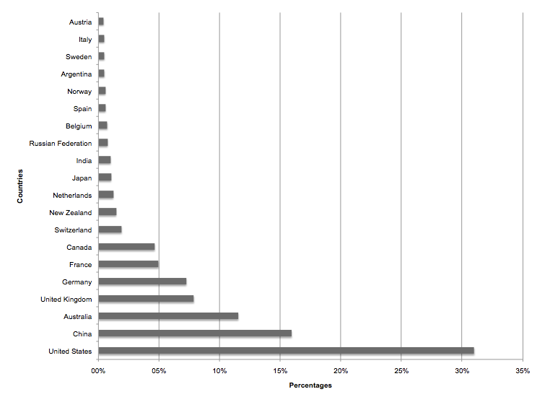
Source: UNTDF, based on data collected from 2018/2019 ship’s dispatches, Argentine Coast Guard.

According to Measure 15 (2009), adopted at the XXXII Antarctic Treaty Consultative Meeting, which recommends a ratio of one guide every 20 passengers, expedition staff members included on the crew and/or on the passenger lists, have been identified. Keeping a direct relationship with passengers, expedition staff members perform different roles, such as expedition leaders, naturalist guides and lecturers, and are in charge of leading passengers during the landing activities. The only trips considered here have been the ones made by vessels that carry 500 passengers or less. In most voyages, expedition staff is included in the passenger manifest, followed by the crew manifest (See Table 4). It is worth mentioning that the expedition staff position is stated only when they are so listed on the crew manifest.

Table 4. Expedition staff reported on the ship’s dispatches. Ushuaia, 2018/2019 summer season

CREW  LIST | PASSENGER LIST | CREW AND PASSENGER LISTS | WITHOUT DATA
26.09% | 36.59% | 2.90% | 34.42%

According to the registration of the vessels that operated in Antarctica throughout this season from Ushuaia, we observed that among the flag States of those vessels, four (4) are Antarctic Treaty Consultative Parties (France, Netherlands, Norway and Russian Federation) and one (1) is a Non-Consultative Party (Portugal). On the other hand, four vessels (4) are not registered to a Party to the Antarctic Treaty (Bahamas, Liberia, Malta and Union of Comoros) (See Figure 5).

Figure 5. Vessel registry. Ushuaia, 2018/2019 summer season

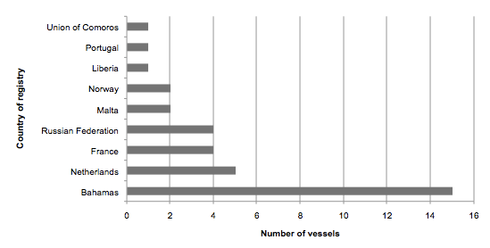
Source: UNTDF, based on data collected from 2018/2019 ship’s dispatches, Argentine Coast Guard.
Concluding remarks
From the gathered data, it has been possible to elaborate statistic information allowing for the identification of the vessels that operated in Antarctica using the port of Ushuaia, during the 2018/2019 season, the number of trips made, the amount of passengers and their nationalities, the average of crew members per vessel, the expedition staff and the countries where the ships are registered.
With regard to the previous season, there is an increase in the number of vessels, voyages and number of passengers. The number of passengers that have visited Antarctica through Ushuaia shows an increase of 28.56%, going from 43,000 during the 2017/2018 season, to 55.282 in the 2018/2019 season, distributed in 278 voyages made by 35 vessels. The number of voyages made by larger vessels that only navigate Antarctic waters has increased to seven (7) trips made by four (4) vessels, transporting 10,964 passengers; showing 56.22% more passengers than the previous season.
The data herein presented aims to contribute, as an alternative and complementary source, in the assessment of tourism in the Antarctic Peninsula region, with special emphasis on those tourist vessels that call in at the port of Ushuaia.

It refers to the inbound and outbound clearance documentation provided by the master of the vessel.
Other small vessels such as MY Game Changer, MY Planet Nine and MY Hanse Explorer are not included in this report.
The average number of passengers on board is taken into account -not the capacity of the vessel, because in some cases it could be that vessels transport a smaller number of passengers than their total capacity.

